**Emergency Reporting System - Android**

**E-R Diagram**

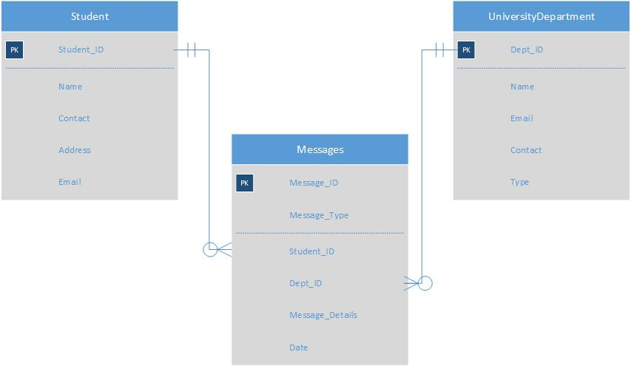

**Prototype Design**

**Screen 1: Log In**

First screen, the user finds login screen when launching the application. The sample prototype of login screen is shown below. The login screen contains two text fields and two buttons. This screen ask the users to login to his/her account to operate the application. By providing the username/e-mail address and corresponding password a user can login directly by clicking the login button. It also provides a Signup option for new user to register a new account for the application. Login button directs user to home page and sign-up button directs to registration page.

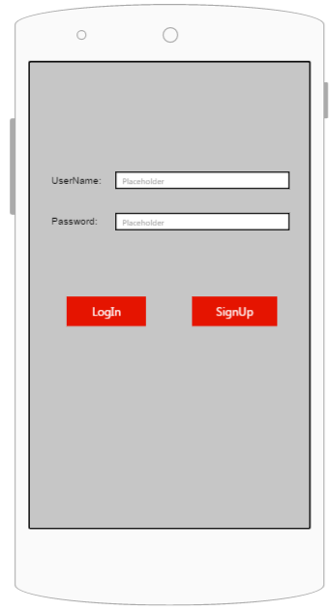

**Screen 2: Registration**

When user clicks on sign-up button it directs to registration page to create a new account for the application. The sample prototype of registration screen is shown below. This screen contains seven text fields, a check button and two buttons. This screen asks a user to register to application by providing appropriate details like user’s first name, last name, e-mail address, password, phone number and address. And by clicking on sign-up button, it validates the credentials, stores user’s data in database and creates an account. The reset button clears all the data entered in text fields.

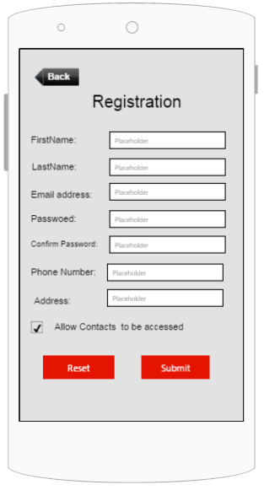

**Screen 3: Home**

As the user login with his credentials, it opens the home screen. The sample prototype of home screen is shown below. This screen contains five buttons namely report to police, Hospital search, Fire emergency, Edit profile and Non-emergency button. When user clicks on report to police and fire emergency button it directs to report to police screens. If user clicks on hospital search button, it directs to Hospital search screen. Edit profile button provides the user to change user’s profile information. Non-emergency button is for complaining an issue to police department.

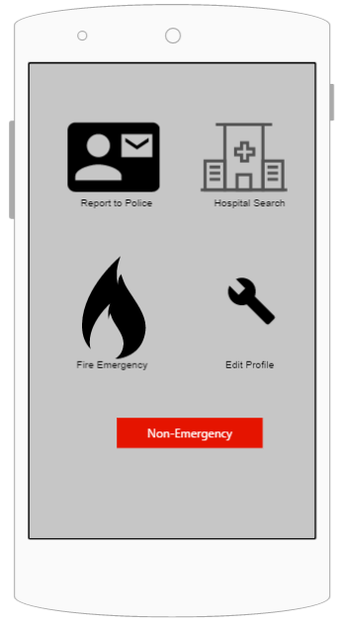

**Screen 4: Report to Police**

The emergency screen appears as user clicks the report to police or fire emergency button in homepage. The sample Prototype of emergency screen is shown below. It provides the user a feedback that the emergency report has been sent to the police department with his location. The emergency information is sent to university police e-mail address.

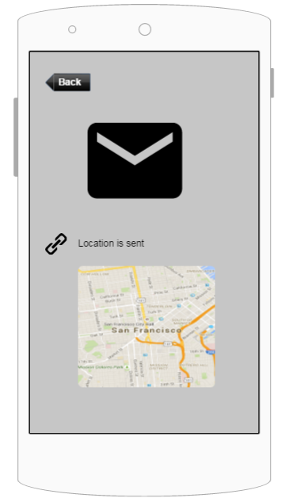

**Screen 5: Hospital**

As user clicks on hospital icon, it directs to hospital screen. This screen is gives the information about nearly available hospitals to user’s location. If user is in medical emergency and if he needs a hospital, this screen provides the nearly available hospitals with the location using google maps.

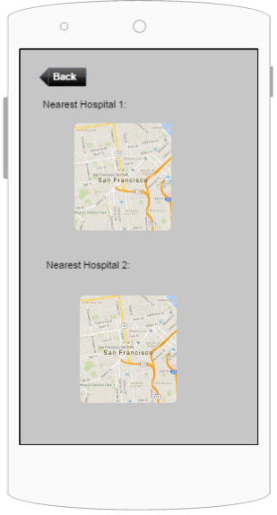

**Screen 6: Edit Profile**

When user clicks on edit profile button on homepage, it opens edit profile screen. The sample prototype of edit profile screen is shown below. This screen contains the various personal and private information of the user. This screen allows the user to change profile credentials. So by just changing the information and clicking on submit button updates the modified details about the user.

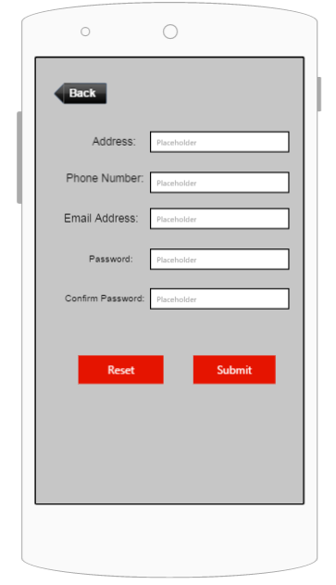

**Screen 7: Non-Emergency**

As user clicks on Non-Emergency button, it directs to Non-Emergency screen, asking the user to upload an image and provide some description about the complaint for reporting an emergency. It has an upload button to attach an image. It contains a Description box to write some information about a complaint submitted to police department. Submit allows the user to submit the report with selected image and description provided in text box.

